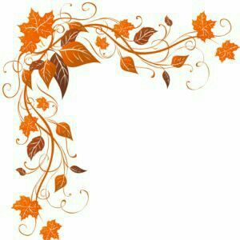

# **We are excited to announce our premier introduction of**

# **Montana Silk Art**

# Sunday, November 18th 1-4 pm

# **Fall into Fashion Fun**

Join us to create your own one-of-a-kind silk scarf!

For yourself, for a Christmas gift, for a shower gift or

for Mom ☺

Visit Lucia’s website for details:

www.montanasilkart.com

$35 per person, includes one scarf, one drink & snacks.

Add’l scarves $25 each same person.

## The Nest on Swan River

600 Three Eagle Lane, Bigfork – 406-261-7542 – TheNestonSwanRiver@gmail.com

Limited spaces available. Call to reserve yours!