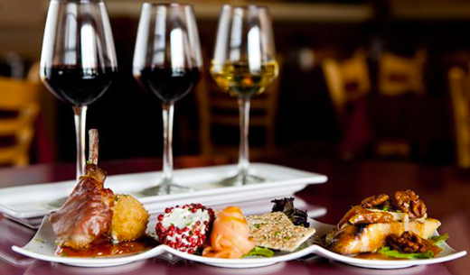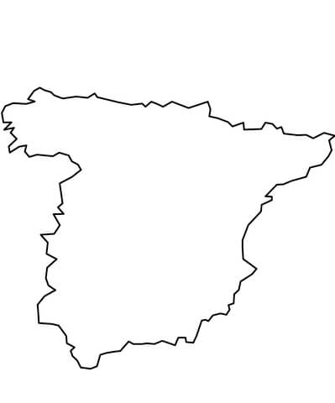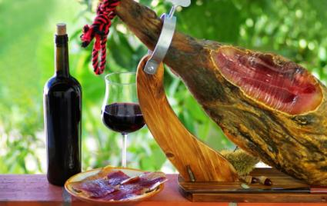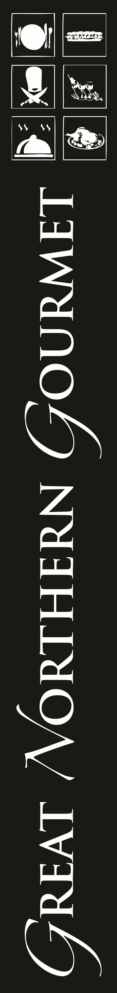

8-Course Spanish Wine

& Tapas Pairing

Featuring Imported

Spanish Cheeses

May 31st 6pm

$89 per person

Call 837-2715 for reservation

Gngmt.com